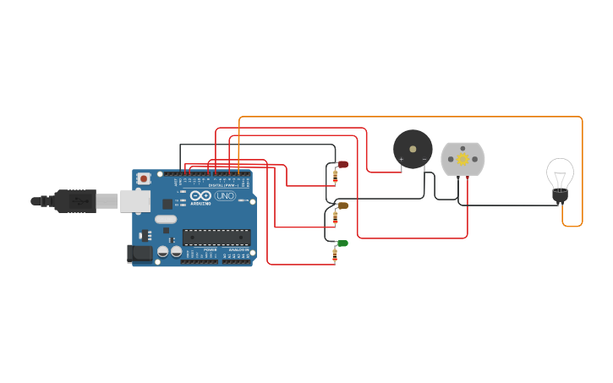

void setup()

{

pinMode(13, OUTPUT);

pinMode(12, OUTPUT);

pinMode(8, OUTPUT);

pinMode(7, OUTPUT);

pinMode(4, OUTPUT);

pinMode(2, OUTPUT);

}

void loop()

{

digitalWrite(2,LOW);

delay(1000);

digitalWrite(2,HIGH);

digitalWrite(4, HIGH);

delay(1000);

digitalWrite(4, LOW);

digitalWrite(7, HIGH);

delay(1000);

digitalWrite(7, LOW);

digitalWrite(13, HIGH);

Serial.println("STOP");

delay(1000); // Wait for 1000 millisecond(s)

digitalWrite(13, LOW);

digitalWrite(12,HIGH);

Serial.println("WAIT");

delay(1000); // Wait for 1000 millisecond(s)

digitalWrite(12, LOW);

digitalWrite(8,HIGH);

Serial.println("GO");

delay(1000);

digitalWrite(8,LOW);

}